**Insecticide Efficacy against the Annual Bluegrass Weevil (Heatherwoode GC)**

Rice Henry, Shaohui Wu

Dept. of Entomology, The Ohio State University, Columbus, OH 43210

**Where:** Heatherwoode Golf Club, Springboro, OH

**Turfgrass:** fairway comprised of a mixture of creeping bentgrass (80%) and annual bluegrass (20%); 1/4 in. thatch.

**Trial plots:** Each plot consisted of 5 ft width by 5 ft length, with 3 ft buffer between adjacent treatments. All treatments were replicated in six blocks, arranged in a randomized complete block design, aligned within 13 ft inside from the fairway edge.

|  |  |  |
| --- | --- | --- |
| **Treatment** | **1st app (1st to 2nd instar, 4/30)** | **2nd app (3rd to 4th instar, 5/14)** |
| T1 | Untreated check | |
| T2 | Suprado |  |
| T3 | Tetrino |  |
| T4 | Ference |  |
| T5 | Plinazolin Tech. |  |
| T6 | Acelepryn |  |
| T7 |  | Suprado |
| T8 |  | Tetrino |
| T9 |  | Ference |
| T10 |  | Plinazolin Tech. |
| T11 |  | Matchpoint |
| T12 |  | Provaunt |
| T13 |  | Dylox |

**Application:** Treatments were applied at 2 gallons per 1000 sq ft at 40 PSI using a two-nozzle CO2 backpack sprayer, followed with 0.1 in. irrigation following each application.

|  |  |  |  |  |  |
| --- | --- | --- | --- | --- | --- |
| **Product** | **Rate** | **Product** | **Rate** | **Product** | **Rate** |
| Suprado | 128 fl oz/A | Tetrino | 32 fl oz/A | Ference | 12 fl oz/A |
| Acelepryn | 12 fl oz/A | Plinazolin | 10.3 fl oz/A | MatchPoint | 16 oz/A |
| Provaunt | 18 oz/A | Dylox | 300 fl oz/A |  |  |

Results were evaluated from plugs taken on May 22nd, when the average larval instar was 5.3. Eight plugs, 2 & 3/8 in. diameter, 2-in. depth, were taken from each plot at least 1 foot from borders. Plugs were kept refrigerated to arrest larval development while results were evaluated. Plugs were torn into quarters and soaked in 10% saline solution for an hour, stirred every 15 minutes to dislodge ABW from the grass. All ABW stages were collected and recorded, with instars evaluated using a microscope.

**Results**

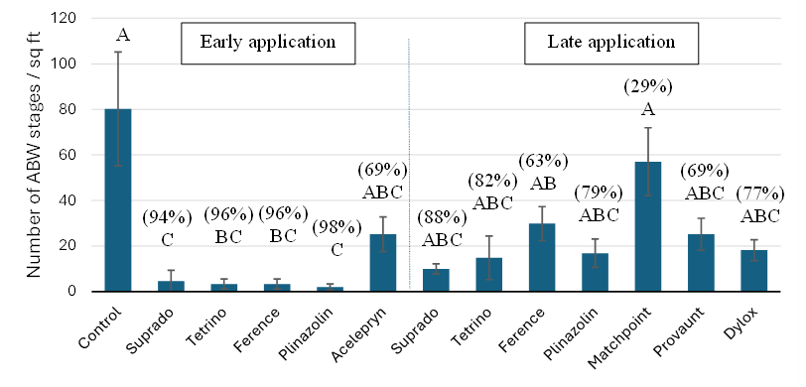

Figure 1. Number of annual bluegrass weevil larvae and pupae (mean ± sem) recovered from various treatments applied at early (1st-2nd instar) and late (3rd-4th instar) stages. The same letters indicate no significant differences between treatments (Tukey’s test, α=0.05). Control% = (1- live counts from treatment/live counts from control) * 100.

* There were significant differences between treatments (F = 6.13, df = 12, 60, *P* < 0.0001)*.*
* All early applications produced lower ABW counts than the untreated control (with ≥ 94% control), except for Acelepryn, with Suprado and Plinazolin Technology being most effective.
* Late applications produced overall lower efficacy, but still achieved ≥ 63% control, except for Matchpoint (only 29%).

**Plot Map (Heatherwoode GC, #11 Fairway)**

|  |  |  |  |  |  |  |  |  |  |  |  |  |  |  |  |  |  |  |  |  |  |  |  |  |
| --- | --- | --- | --- | --- | --- | --- | --- | --- | --- | --- | --- | --- | --- | --- | --- | --- | --- | --- | --- | --- | --- | --- | --- | --- |
| **Ⅱ 8** |  | **Ⅱ 4** |  | **Ⅱ 6** |  | **Ⅱ 12** |  | **Ⅱ 11** |  | **Ⅱ 9** |  | **Ⅱ 13** |  | **Ⅱ 3** |  | **Ⅱ 2** |  | **Ⅱ 1** |  | **Ⅱ 10** |  | **Ⅱ 7** |  | **Ⅱ 5** |
|  |  |  |  |  |  |  |  |  |  |  |  |  |  |  |  |  |  |  |  |  |  |  |  |  |
| **Ⅰ 10** |  | **Ⅰ 12** |  | **Ⅰ 1** |  | **Ⅰ 3** |  | **Ⅰ 7** |  | **Ⅰ 5** |  | **Ⅰ 6** |  | **Ⅰ 4** |  | **Ⅰ 13** |  | **Ⅰ 9** |  | **Ⅰ 11** |  | **Ⅰ 2** |  | **Ⅰ 8** |

|  |  |  |  |  |  |  |  |  |  |  |  |  |  |  |  |  |  |  |  |  |  |  |  |  |
| --- | --- | --- | --- | --- | --- | --- | --- | --- | --- | --- | --- | --- | --- | --- | --- | --- | --- | --- | --- | --- | --- | --- | --- | --- |
| **Ⅳ 3** |  | **Ⅳ 1** |  | **Ⅳ 13** |  | **Ⅳ 6** |  | **Ⅳ 10** |  | **Ⅳ 4** |  | **Ⅳ 11** |  | **Ⅳ 9** |  | **Ⅳ 8** |  | **Ⅳ 5** |  | **Ⅳ 2** |  | **Ⅳ 7** |  | **Ⅳ 12** |
|  |  |  |  |  |  |  |  |  |  |  |  |  |  |  |  |  |  |  |  |  |  |  |  |  |
| **Ⅲ 8** |  | **Ⅲ 12** |  | **Ⅲ 5** |  | **Ⅲ 1** |  | **Ⅲ 6** |  | **Ⅲ 4** |  | **Ⅲ 11** |  | **Ⅲ 7** |  | **Ⅲ 13** |  | **Ⅲ 9** |  | **Ⅲ 10** |  | **Ⅲ 3** |  | **Ⅲ 2** |

|  |  |  |  |  |  |  |  |  |  |  |  |  |  |  |  |  |  |  |  |  |  |  |  |  |
| --- | --- | --- | --- | --- | --- | --- | --- | --- | --- | --- | --- | --- | --- | --- | --- | --- | --- | --- | --- | --- | --- | --- | --- | --- |
| **Ⅵ 5** |  | **Ⅵ 6** |  | **Ⅵ 12** |  | **Ⅵ 9** |  | **Ⅵ 4** |  | **Ⅵ 7** |  | **Ⅵ 1** |  | **Ⅵ 8** |  | **Ⅵ 2** |  | **Ⅵ 11** |  | **Ⅵ 13** |  | **Ⅵ 3** |  | **Ⅵ 10** |
|  |  |  |  |  |  |  |  |  |  |  |  |  |  |  |  |  |  |  |  |  |  |  |  |  |
| **Ⅴ 2** |  | **Ⅴ 4** |  | **Ⅴ 9** |  | **Ⅴ 11** |  | **Ⅴ 3** |  | **Ⅴ 8** |  | **Ⅴ 1** |  | **Ⅴ 6** |  | **Ⅴ 10** |  | **Ⅴ 13** |  | **Ⅴ 5** |  | **Ⅴ 12** |  | **Ⅴ 7** |